# C:\Users\jamiea\Desktop\banner.png



Freshly made every day!

**st mary’s ce primary, runcorn**

**week 1**

**week 1**

# 

|  |  |  |  |  |  |  |
| --- | --- | --- | --- | --- | --- | --- |
| **Day** | peas  **Choice 1** | **Choice 2** | **Choice 3** | | **PUDDING** | |
| banner  **Monday** | Cheese & Tomato Pizza  served with Herby Diced Potatoes and Mixed Salad | Macaroni Cheese  served with Garlic Bread and Mixed Salad | | Assorted Sandwiches  filled with Ham, Cheese or Tuna served with Mixed Salad | | Flapjack  or  Frozen Yoghurt or Fruit Salad | |
| banner  **Tuesday** | All Day Breakfast  served with Bacon, Sausage, Hash Brown and Beans | Veggie Breakfast  served with Vegan Sausage, Egg and  Hash Brown | | Oven Baked Jacket Potato  filled with Cheese, Tuna or Beans served with Mixed Salad | | Jam & Coconut Sponge  or  Frozen Yoghurt or Fruit Salad | |
| banner  **Wednesday** | Roast Chicken Fillet  served with Creamed Potato, Mixed Veg and Gravy | Quorn Fillet  served with Creamed Potato, Mixed Veg and Gravy | | Assorted Tortilla Wrap  filled with Ham, Cheese or Tuna served with Mixed Salad | | Chocolate Brownie  or  Yoghurt or Fruit Salad | |
| banner  **Thursday** | Beef Burger in a Bun  served with Seasoned Wedges and Sweetcorn | Veggie Meatballs in Tomato Sauce  served with Garlic Bread and Sweetcorn | | Assorted Sandwiches  filled with Ham, Cheese or Tuna served with Mixed Salad | | Marble Sponge & Custard  or  Frozen Yoghurt or Fruit Salad | |
| bannerbanana  **Friday** | Fish Fingers  served with Chips and  Baked Beans | Hot Roasted Vegetable Wrap  served with Chips and Baked Beans | | Oven Baked Jacket Potato  filled with Cheese, Tuna or Beans served with Mixed Salad | | Chocolate Chip Cookie  or  Yoghurt or Fruit Salad | |

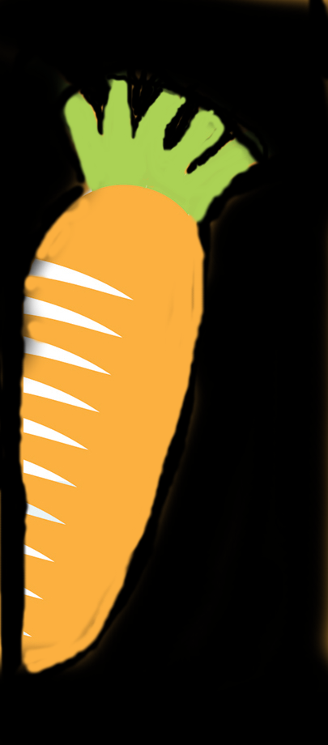

C:\Users\jamiea\Desktop\Branding and marketing\OrianLogoSquare.tif

Available Daily: Fresh Fruit and Salad Bar

**If you have any questions about food allergens, please speak to the kitchen team who will be happy to help.**

**ORFORM44 ISSUE 1 – 18.10.18 SPRING/SUMMER 2024**

# C:\Users\jamiea\Desktop\banner.png

**st mary’s ce primary, runcorn**

**week 2**



Freshly made every day!

# 



|  |  |  |  |  |  |  |
| --- | --- | --- | --- | --- | --- | --- |
| **Day** | peas  **Choice 1** | **Choice 2** | **Choice 3** | | **PUDDING** | |
| banner  **Monday** | Cheese & Tomato Pizza  served with Seasoned Wedges and Sweetcorn | Tomato & Basil Pasta  served with Garlic Bread and Sweetcorn | | Assorted Sandwiches  filled with Cheese, Ham or Tuna served with Mixed Salad | | Cherry Shortbread  or  Frozen Yoghurt or Fruit Salad | |
| banner  **Tuesday** | Breaded Chicken Goujons  served with Creamed Potato and Garden Peas | Crustless Vegetable Quiche  served with Seasoned Wedges and Mixed Salad | | Oven Baked Jacket Potato  filled with Tuna, Cheese or Beans served with Mixed Salad | | Cornflake Tart  or  Yoghurt or Fruit Salad | |
| banner  **Wednesday** | Sliced Cooked Beef  served with Yorkshire Pudding, Roast Potatoes, Sliced Carrots and Gravy | Cheese & Potato Pie  served with Roast Potatoes,  Sliced Carrots and Gravy | | Assorted Tortilla Wrap  filled with Ham, Cheese or Tuna served with Mixed Salad | | Muffin  or  Frozen Yoghurt or Fruit Salad | |
| banner  **Thursday** | Chilli Beef Con Carne  served with Basmati Rice and Sweetcorn | Vegetarian Korma  served with Basmati Rice and Garlic Bread | | Assorted Sandwiches  filled with Cheese, Ham or Tuna served with Mixed Salad | | Rice Crispie Crunch  or  Yoghurt or Fruit Salad | |
| bannerbanana  Available Daily: Fresh Fruit and Salad Bar  **Friday** | Fish Fingers  served with Chips and  Garden Peas | Quorn Goujons  served with Chips and  Garden Peas | | Oven Baked Jacket Potato  filled with Cheese, Beans or Tuna served with Mixed Salad | | Syrup Sponge & Custard  or  C:\Users\jamiea\Desktop\Branding and marketing\OrianLogoSquare.tifFrozen Yoghurt or Fruit Salad | |



**If you have any questions about food allergens, please speak to the kitchen team who will be happy to help.**

**ORFORM44 ISSUE 1 -18.10.18 SPRING/SUMMER 2024**

# C:\Users\jamiea\Desktop\banner.png

**st mary’s ce primary, runcorn**

**week 3**



Freshly made every day!

# 

|  |  |  |  |  |  |  |
| --- | --- | --- | --- | --- | --- | --- |
| **Day** | peas  **Choice 1** | **Choice 2** | **Choice 3** | | **PUDDING** | |
| banner  **Monday** | Cheese & Tomato Pizza  served with Cheesy Jacket Skins and Mixed Salad | Roasted Vegetable Pasta  served with Garlic Bread and Mixed Salad | | Assorted Sandwiches  filled with Cheese, Ham or Tuna served with Mixed Salad | | Vanilla & Jam Cookie  or  Frozen Yoghurt or Fruit Salad | |
| banner  **Tuesday** | Hot BBQ Chicken Sandwich  served with Nachos and Mixed Salad | Cheese Bean Enchiladas  served with Garlic Bread and Sweetcorn | | Oven Baked Jacket Potato  filled with Tuna, Cheese or Beans served with Mixed Salad | | Banana Cake  or  Frozen Yoghurt or Fruit Salad | |
| banner | Sliced Cooked Turkey  served with Creamed Potato, Garden Pea & Carrot Medley and Gravy | Vegetable Sausage  served with Creamed Potato, Garden Pea & Carrot Medley and Gravy | | Assorted Tortilla Wrap  filled with Cheese, Ham or Tuna served with Mixed Salad | | Chocolate Shortbread  or  Frozen Yoghurt or Fruit Salad | |
| banner  **Thursday** | Tuna & Sweetcorn Pasta Bake  served with Garlic Bread and Sweetcorn | Veggie Chilli  served with Basmati Rice and Sweetcorn | | Assorted Sandwiches  filled with Cheese, Ham or Tuna served with Mixed Salad | | Iced Lemon Sponge  or  Yoghurt or Fruit Salad | |
| bannerbanana  **Friday** | Breaded White Fish Fillet  served with Chips and Garden Peas | Vegetarian Hot Dog  served with Chips and Garden Peas | | Oven Baked Jacket Potato  filled with Cheese, Beans or Tuna served with Mixed Salad | | Orange Jelly  or  Frozen Yoghurt or Fruit Salad | |



**Wednesday**

C:\Users\jamiea\Desktop\Branding and marketing\OrianLogoSquare.tif

Available Daily: Fresh Fruit and Salad Bar

**If you have any questions about food allergens, please speak to the kitchen team who will be happy to help.**

**ORFORM44 ISSUE 1 – 18.10.18 SPRING/SUMMER 2024**