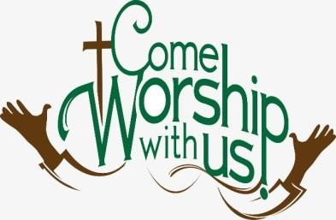**Pupil Voice Collective Worship** - Results 2024

Children were asked what they thought about Collective

Worship. They were also given freedom to make any suggestions as to how our worship could be improved, changed or adapted.

# What the children said

Children said that they love singing during Collective Worship. They love songs that they are familiar with, but equally love learning new songs. When prompted for favourites they listed –

* ‘Let’s Go’
* ‘I’m Following the King’
* ‘My Jesus, My Saviour’
* ‘God we love you’

They love songs with actions and don’t feel embarrassed at all to join in. They said they feel it helps the little ones. One child shared that they like songs that make them think about themselves and what they should be doing.

Children like hearing stories especially stories from the Bible. One child said that the Bible really tells him how he should live his life and that he is always left thinking about something that will make him a better person. A few children said that real life stories inspire them, and one child said that it made him think about what he wanted to do with his life when he is older. Another child said he feels motivated when he hears the stories we share.

Many children said that they like the fact that they are given an opportunity to ask questions after hearing a story and often get to express their own opinions. They also love it when stories are interactive and volunteers are asked for.

Some of the outside speakers they mentioned were

* Tony the vicar – they love the way he allows them to question what they have heard
* David – the Methodist Pastor who uses puppets
* Hope Corner Kids – they love the singing and interactions with volunteers.
* The Foundry Church who make learning about Jesus fun.

One child said that without the Bible assemblies would be boring.

# Values

All children agree that working on shared values really helps them to focus upon doing things right. One child said that values help him express his own feelings and makes him wonder how he should treat others. Another said that the Bible gives us the reason for the value and the values help us understand what Jesus did and what God is like.

All children love the fact that they are recognised for demonstrating values and the reward system of awarding beads in a jar is effective.

Children love the assemblies held on Fridays where they get to be praised for various achievements. They also love celebrating birthdays.

Children also like the fact that they get to evaluate Collective Worship sessions and have noted that notice is taken of these evaluations and changes have been made.

# Prayer

Children said that they like praying and feel that this shows their respect for God. They understand that prayer is talking to God. They like to think about the words and take their time with prayer. They also like saying the Grace and holding hands to do this.

# Special Worship times

Children love the end of term visits to St Mary’s Church but would like to do this more often. They said it reminds them that we are a church school. They love the walk up to church with the whole school.

They also love the fun Headteacher assemblies at the end of the year and at Christmas.

# Changes requested

When asked for improvements, many said they could not think of anything. Some older boys would like some more interactive assemblies in KS 2 - perhaps with more singing. They would also like the opportunity to volunteer more often.

Some children said they would like to go to church more frequently.